SL4J Logging exercises OUTPUT

Name : Ganta Sri Ratna Hemanth

Superset id : 6124988

1. Logging Error Messages and Warning Levels

**Step – 1 :** Create a maven project and add sl4j to its dependency in pom.xml

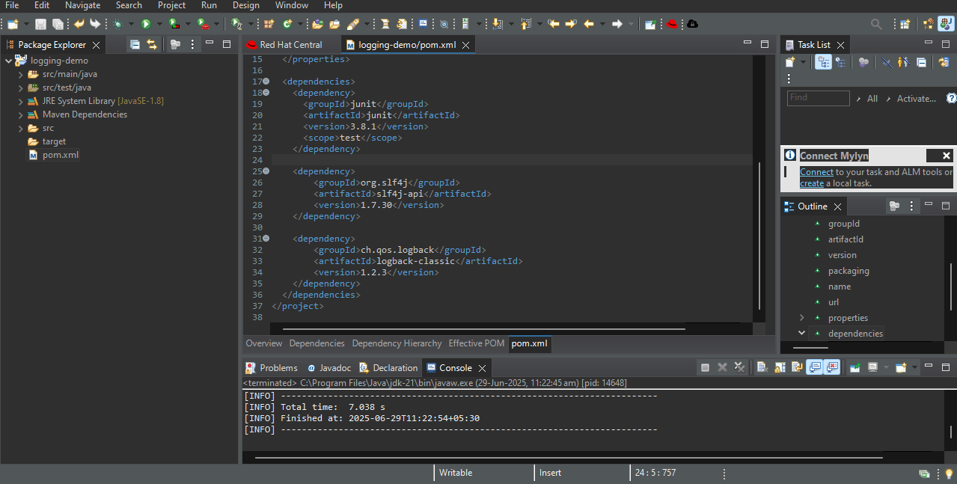

**Step – 2 :** Createaclass named LoggingExample in src/main/java and write the code.

**CODE :**

package com.example.logging_demo;

import org.slf4j.Logger;

import org.slf4j.LoggerFactory;

public class LoggingExample {

private static final Logger ***logger*** = LoggerFactory.*getLogger*(LoggingExample.class);

public static void main(String[] args) {

***logger***.error("This is an error message");

***logger***.warn("This is a warning message");

}

}

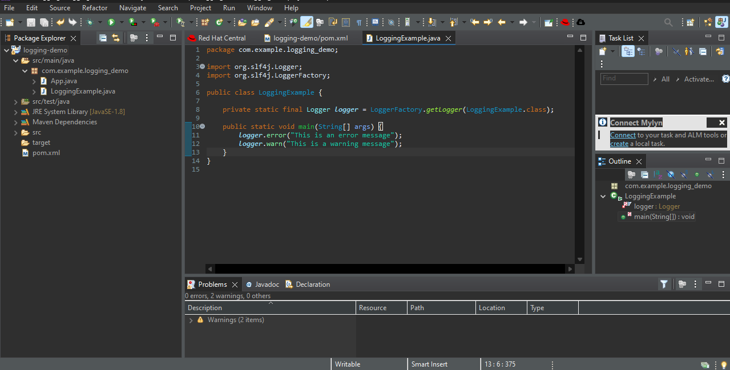

OUTPUT :

Run the code as java application

